**Political Advertising in 2014: The Year of the Outside Group[1]**

Erika Franklin Fowler, Wesleyan University

&

Travis N. Ridout, Washington State University

**Abstract**

The volume of televised political advertising plateaued in 2014, as did levels of negativity. Yet the most interesting story about this advertising was the extensive involvement of outside groups, many of which did not disclose their donors. In many of the most competitive Senate races, groups surpassed the parties—and sometimes even the candidates—as the primary sponsors of political advertising. We speculate on what these patterns from 2014 are likely to mean for advertising in 2016.

**Erika Franklin Fowler** is Assistant Professor of Government at Wesleyan University and Co-Director of the Wesleyan Media Project. She specializes in political communication – local media and campaign advertising in particular – and her work on local news coverage of politics and policy has been published in political science, communication, law/policy, and medical journals.

**Travis N. Ridout** is Thomas S. Foley Distinguished Professor of Government and Public Policy and Associate Professor in the School of Politics, Philosophy, and Public Affairs at Washington State University. He is Co-Director of the Wesleyan Media Project and author of *The Persuasive Power of Campaign Advertising* (Temple University Press, 2011).

**Political Advertising in 2014: The Year of the Outside Group**

The trend toward ever-increasing volumes of televised political advertising ended in 2014. Though there was certainly no dearth of ads in the 2014 midterm elections, 2014 was not a year of record-setting ad volumes. And while there was still plenty of negative advertising as well, 2014 was not a year of record-setting negativity either. There was one feature of 2014 advertising, however, that was noteworthy compared with past campaigns. This distinguishing feature was the large extent to which outside groups were involved in the most competitive races, with their presence being especially felt in races for U.S. Senate.

In this article, we provide an overview of how many ads aired in federal and gubernatorial campaigns in 2014, how much was spent on them, and where they aired. In doing so, we make a case that advertising in 2014 was, at least to a small extent, concentrated in the most competitive races, while beginning earlier than in previous election cycles. The reason for both of those trends, we posit, is the increasing number of ads being sponsored by outside groups. In addition, we focus on how “dark money” groups—those who do not disclose their donors—along with new full-disclosure groups have become an important part of the campaign advertising landscape. Finally, we consider how the issue content of advertising in 2014 compares with past election cycles. We find that the issue of jobs has faded as the unemployment rate has dropped, but that the Affordable Care Act (aka Obamacare) remains an oft-mentioned topic in Republican advertising.

Our primary source of data on advertising during the 2014 campaigns is the Wesleyan Media Project (WMP), which is a collaboration of researchers at Wesleyan University, Bowdoin College, and Washington State University. The project, which first started tracking political advertising in 2010—and is a successor to the Wisconsin Advertising Project—obtains data from a commercial firm, Kantar Media/CMAG, that details the placement of each political ad aired on broadcast television in all 210 media markets in the United States. Included in these data are information about the station on which each ad aired, the time it aired, its length, and an estimate of its cost.

WMP staff then watches each unique ad and codes for dozens of different characteristics, including the issues mentioned and the ad’s tone.[2] In general, inter-coder reliability was quite high.[3] Although the WMP data do give a fairly comprehensive picture of television advertising, data on ads aired on local cable television are not included in the ad counts or cost estimates. Yet although campaigns have increasingly turned to local cable in the past decade for its ability to target particular geographic areas and audiences, most campaigns still spend a relatively small proportion of their campaign budgets on local cable.

**Volume of Advertising**

As mentioned, advertising was still ubiquitous in 2014 but plateaued in terms of volume. An estimated $1.4 billion was spent on a total of 2,516,513 airings in federal and gubernatorial races in 2014, as Table 1 shows.

|  |  |  |
| --- | --- | --- |
| Table 1: Volume of Ads and Estimated Spending (January 1-Election Day) | | |
|  |  |  |
|  | Est. Cost | Airings |
| Governor | $598.9 M | 943,152 |
| House | $325.8 M | 592,767 |
| Senate | $488.7 M | 980,594 |
| Total | $1,413.4 M | 2,516,513 |

This volume is a 13.7 percent decrease (Table 2) from 2010, the most comparable prior year given that the number of gubernatorial elections held is substantially higher in midterm years. The drop in volume from 2010 was driven by a decrease in gubernatorial airings from over 1.3M airings in 2010 to 943,152 in 2014. Ad airings in House and Senate races combined have held relatively steady around 1.6 million in the past three election cycles, up from 1.15 million in 2008. The bulk of the advertising activity shifted to the battle for the Senate in 2014, with 980,594 airings compared to only 592,767 for U.S. House. (In 2008 and 2010, airings for both houses were roughly equivalent). Senate airings were also up over 2012 levels, at 980,594 compared to 925,135.

|  |  |  |  |  |
| --- | --- | --- | --- | --- |
| Table 2: Volume of Ads by Race and Year (January 1-Election Day) | | | | |
|  |  |  |  |  |
|  | 2008 | 2010 | 2012 | 2014 |
| Governor | 190,315 | 1,305,777 | 229,163 | 943,152 |
| House | 553,130 | 767,541 | 685,787 | 592,767 |
| Senate | 593,875 | 788,922 | 925,135 | 980,594 |
| Total | 1,337,320 | 2,862,240 | 1,840,085 | 2,516,513 |
|  |  |  |  |  |

Throughout the first decade of the 2000s, the volume of political advertising continued to rise with each election, though it appears to have plateaued in the past three election cycles. One reason for this might be that campaigns are becoming more adept at targeting (Issenberg 2012). Although broadcast television allows for some geographic and audience targeting, the amount of precision one can gain by using local cable television is much greater than with broadcast television. A second reason that the volume of advertising may have plateaued is that campaigns are slowly moving resources to online and social media. Although online advertising was expected to account for only 3 percent of campaign ad dollars in 2014, that percentage was expected to rise to 7.7 percent in 2016 (Klimas 2014). Finally, the experience of the 2012 presidential campaign, in which more and more ads chased the same eyeballs with seemingly little movement in opinion, may have sent a message to campaigns to use their money in other ways, as evidenced by the large ground-game efforts in 2014 by Americans for Prosperity and Planned Parenthood Votes (Kucinich 2014).

Of course, the 2014 midterms were bad news for Democrats, who lost over a dozen House seats and nine seats in the Senate. Yet one might not have predicted the huge Democratic losses that transpired on the basis of the distribution of advertising between the two major parties. Although Republicans topped Democrats in gubernatorial airings (319,431 to 278,542) during the general election period from September 1, 2014, to Election Day, Democrats held aggregate advantages in the House (249,911 compared to 183,161 for Republicans) and in Senate races (283,917 compared to 251,668 for Republicans).

Figure 1 shows the aggregate partisan advantage in general election airings by market in U.S. House and U.S. Senate races from September 1 to Election Day. The top 15 media markets by ad volume for each race are outlined in bold. The figure reveals that Democrats held advantages in all of the top markets for House races and most of the top markets for Senate races. However, Republicans maintained advantages in most of Iowa, and in much of Kentucky and Arkansas. Denver, Colorado, not only saw the most House and Senate ads of any media market in 2014 but saw the most advertising across all races as well.

Figure 1. Partisan Advantage in U.S. Senate (top panel) and U.S. House Races (bottom panel), September 1 to Election Day

South Carolina totals were as follows: 172 pro-Democratic ads, 542 pro-Republican ads and 466 pro-other party ads in Columbia, 151 pro-Democratic, 429 pro-Republican and 475 pro-other party ads in Charleston, and 3,643 pro-Democratic, 1,937 pro-Republican and 843 pro-other party ads in Greenville.

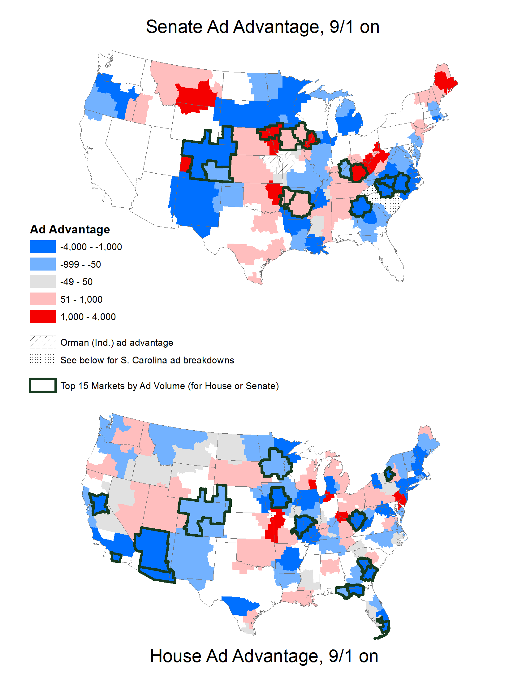

The North Carolina contest between incumbent Kay Hagan and challenger Thom Tillis earned the distinction for the highest volume of Senate airings, at 69,349 ads aired between September 1 and Election Day at an estimated cost of $52.6 million (Table 3). Iowa was a close second with 62,186 ads and was followed by Kentucky (46,979 ads), Colorado (43,587 ads), and Louisiana (39,550).

|  |  |  |  |  |
| --- | --- | --- | --- | --- |
| Table 3: Top Senate Races by Volume (September 1 to Election Day) | | | | |
| State | Total ads | Dem ads | Rep ads | Total $s |
| North Carolina | 69,349 | 40,224 | 29,125 | $52.6 M |
| Iowa | 62,186 | 28,809 | 33,377 | $25.2 M |
| Kentucky | 46,979 | 21,537 | 25,439 | $26.3 M |
| Colorado | 43,587 | 22,763 | 20,700 | $34.2 M |
| Louisiana | 39,550 | 23,393 | 16,157 | $17.9 M |
| Georgia | 37,192 | 21,830 | 15,362 | $27.1 M |
| Arkansas | 32,164 | 16,425 | 15,739 | $17.3 M |
| Alaska | 28,889 | 14,570 | 14,319 | $4.2 M |
| Michigan | 28,426 | 18,592 | 9,834 | $20.9 M |
| Kansas | 22,310 | 19 | 10,487 | $11.3 M |
|  |  |  |  |  |

Figure 2 traces the volume of advertising over time in the most competitive Senate races from September 1 to Election Day. Observations above the horizontal line at 0 indicate days on which pro-Republican ads outnumbered pro-Democratic ads, while observations below the line indicate a Democratic advantage. In most races, there was little fluctuation week-to-week in the balance of pro-Republican and pro-Democratic advertising, though a few races do stand out. One is North Carolina’s Senate race, where the extent of the Democratic advantage continued to build as Election Day approached. Virginia and Georgia show a somewhat weaker version of that same pattern. Kentucky and Iowa are the only two races that appeared to have slight but relatively consistent Republican advantages in the final few weeks of the campaign.

Figure 2: Partisan Advantage Over Time in U.S. Senate Contests (September 1 to Election Day)



One notable feature of Senate advertising in 2014 was that advertising was more concentrated in the top races than in previous election cycles, as Table 4 reveals. In 2010, 36.2 percent of total Senate ad airings were found in the top five races by volume, but by 2014, that percentage had risen to 47.3 percent. In other words, almost half of Senate ad airings occurred in just five of the 33 races on the ballot across the country. And nearly three-fourths (74.3 percent) of Senate ad airings occurred in the ten races with the highest volume of advertising, up from 65.9 percent in 2010.

|  |  |  |
| --- | --- | --- |
| Table 4: Percentage of Senate Ads in Highest Volume Races (January 1 to Election Day) | | |
|  |  |  |
| Year | Percent in Top 5 | Percent in Top 10 |
| 2010 | 36.2 | 65.9 |
| 2012 | 42.1 | 68.6 |
| 2014 | 47.3 | 74.3 |
|  |  |  |

Table 5 lists the top House races in 2014 in terms of ad volume from September 1 to Election Day. Georgia’s 12th district contest between incumbent Democrat John Barrow and Republican challenger Rick Allen topped the list of congressional races with a whopping 26,137 ads aired between September 1 and Election Day. Barrow’s commanding lead in the air war did not result in victory, however, and he lost to Allen by 9.6 points. Florida’s 2nd district had the second highest volume of advertising with 22,116 ad airings. Democratic challenger Gwen Graham (and daughter of former Senator Bob Graham) amassed an advertising advantage of over 2,000 ads over incumbent Steve Southerland, which may have contributed to her eventual victory. Arizona’s 2nd and West Virginia’s 3rd districts, both of which featured vulnerable Democratic incumbents, also topped the list of House races with more than 15,000 ads aired in the final two months of the campaign.

|  |  |  |  |  |
| --- | --- | --- | --- | --- |
| Table 5: Top House Races by Volume (September 1 to Election Day) | | | | |
|  |  |  |  |  |
| District | Total Ads | Pro-Dem | Pro-GOP | Est. Cost |
| Georgia 12 | 26,137 | 16,216 | 9,921 | $9.1 M |
| Florida 02 | 22,116 | 12,352 | 9,764 | $6.8 M |
| Arizona 02 | 20,835 | 11,438 | 9,397 | $8.3 M |
| West Virginia 03 | 15,532 | 8,639 | 6,893 | $4.0 M |
| Arizona 01 | 13,653 | 8,634 | 5,019 | $14.4 M |
| California 52 | 13,584 | 8,110 | 5,474 | $10.2 M |
| Illinois 12 | 12,910 | 8,122 | 4,788 | $7.1 M |
| California 10 | 12,897 | 6,658 | 6,239 | $10.5 M |
| Iowa 03 | 11,986 | 7,590 | 4,396 | $4.6 M |
| Minnesota 08 | 11,920 | 7,626 | 4,294 | $8.4 M |
|  |  |  |  |  |

Advertising in House races in 2014 was also more highly concentrated in the top races, with 27 percent of airings occurring in the top 10 races compared to roughly 21 percent in 2010 (Table 6). Nearly 50 percent of all House ad airings occurred in the top 25 races nationwide in 2014, compared to roughly 42 percent in 2010.

|  |  |  |
| --- | --- | --- |
| Table 6: Percentage of House Ads in Highest Volume Races (January 1 to Election Day) | | |
| Year | Top 10 | Top 25 |
| 2010 | 20.7 | 41.8 |
| 2012 | 23.3 | 44.8 |
| 2014 | 27.3 | 49.4 |
|  |  |  |

Turning to races for governor (Table 7), we see that Florida’s race was on top—and by a large margin—in the volume of ads aired. Over 100,000 gubernatorial ads aired in the state between September 1 and Election Day, almost two-thirds of them favoring Republican Rick Scott. Texas saw almost 60,000 ads in the same time frame, and again advertising heavily favored the Republican candidate. Wisconsin, Illinois, and Michigan each had over 40,000 ad airings.

|  |  |  |  |  |
| --- | --- | --- | --- | --- |
| Table 7: Top Governor Races by Ad Volume (September 1 to Election Day) | | | | |
|  |  |  |  |  |
| State | Total ads | Dem ads | Rep ads | Total $s |
| Florida | 106,523 | 37,303 | 69,220 | $69.4 M |
| Texas | 59,979 | 18,769 | 41,199 | $34.2 M |
| Wisconsin | 47,963 | 27,867 | 20,096 | $20.1 M |
| Illinois | 46,640 | 24,742 | 21,898 | $52.6 M |
| Michigan | 42,863 | 18,018 | 24,845 | $27.0 M |
| Kansas | 25,103 | 12,485 | 12,618 | $11.7 M |
| Georgia | 24,294 | 12,821 | 11,441 | $15.9 M |
| New York | 23,920 | 20,303 | 3,594 | $17.9 M |
| Maine | 19,844 | 10,453 | 7,140 | $6.5 M |
| Pennsylvania | 17,592 | 9,424 | 8,168 | $16.0 M |
|  |  |  |  |  |

In contrast to House and Senate races, advertising in gubernatorial races was not more concentrated in 2014 than in the past (Table 8). In 2014, 46.1 percent of ads aired in the top 5 races, which compares with 51.4 percent in 2010—the previous year with the same number of gubernatorial races. One reason for this is that the race for governor of California in 2010 featured considerable advertising—over 200,000 ad airings—while that state’s race was not remotely competitive in 2014. Concentration in the top ten races was quite similar in 2010 and 2014, with about 69 percent of ads being aired in those top ten races in both years.

|  |  |  |
| --- | --- | --- |
| Table 8: Percentage of Governor Ads in Highest Volume Races (January 1 to Election Day) | | |
|  |  |  |
| Year | Percent in Top 5 | Percent in Top 10 |
| 2010 | 51.4 | 69.5 |
| 2014 | 46.1 | 69.1 |
|  |  |  |

Another feature of advertising in 2014 that is worth remarking on is that advertising started earlier—at least in Senate and House races. By June 1, over 18 percent of total Senate ads had already aired, which compares to 12.4 percent in 2012 and 14.7 percent in 2010 (Table 9). And by September 1, 43.7 percent of Senate ads had aired, up from 39.4 percent in 2012 and 37.5 percent in 2010. A similar pattern is seen in House advertising. By June 1, 13.6 percent of total House ads in 2014 had aired, up from 10 percent in 2012 and 6.6 percent in 2010. By September 1, almost 27 percent of the House ads in 2014 had aired, considerably higher than the 21.3 percent that had aired by the same point in 2012 and the 18.6 percent that had aired by the same point in 2010.

|  |  |  |  |  |  |  |  |  |
| --- | --- | --- | --- | --- | --- | --- | --- | --- |
| Table 9: Percentage of Ads Airing before June 1 and September 1 in Senate, House and Governor Races (January 1- Election Day) | | | | | | | | |
|  | |  | |  | |  | | |
|  | | U.S. Senate | | U.S. House | | Governor | | |
|  | Before  June 1 | | Before  Sept 1 | Before  June 1 | Before Sept 1 | Before  June 1 | Before Sept 1 |
| 2010 | 14.7 | | 37.5 | 6.6 | 18.6 | 23.5 | 49.4 |
| 2012 | 12.4 | | 39.4 | 10.0 | 21.3 | 28.3 | 42.4 |
| 2014 | 18.1 | | 43.7 | 13.6 | 26.9 | 14.5 | 36.0 |
|  |  | |  |  |  |  |  |

The exception to the rule of earlier advertising in 2014 was races for governor, where advertising arrived later than in the two previous election cycles. For instance, only 14.5 percent of gubernatorial ads had aired before June 1 in the 2014 cycle, compared in 28.3 percent in 2012 and 23.5 percent in 2010. The pattern is the same if one examines gubernatorial ads aired before September 1. We will offer some speculation about these patterns in the next section.

**The Year of the Outside Group?**

One prominent storyline from 2014 was the extent to which independent groups were involved in advertising. Certainly, the overall percentage of ads sponsored by groups was higher in 2014 (25.7 percent) than in any of the three previous election cycles, as the last column of Table 10 shows. That said, that percentage is only slightly higher than the 24.6 percent of total ads that groups sponsored in 2012.

|  |  |  |  |  |
| --- | --- | --- | --- | --- |
| Table 10: Ad Sponsorship by Office and Year (January 1-Election Day) | | | | |
|  |  |  |  |  |
| 2008 | Senate | House | Gov | Total |
| Candidate | 60.8% | 74.1% | 80.6% | 69.1% |
| Party/Coordinated | 25.4% | 20.2% | 2.0% | 20.0% |
| Group | 13.7% | 5.6% | 17.3% | 10.9% |
|  |  |  |  |  |
| 2010 | Senate | House | Gov | Total |
| Candidate | 67.5% | 73.2% | 79.5% | 74.5% |
| Party/Coordinated | 20.0% | 12.0% | 7.7% | 12.2% |
| Group | 12.6% | 14.8% | 12.8% | 13.3% |
|  |  |  |  |  |
| 2012 | Senate | House | Gov | Total |
| Candidate | 59.6% | 58.8% | 67.1% | 60.2% |
| Party/Coordinated | 12.9% | 23.2% | 0.4% | 15.2% |
| Group | 27.5% | 18.0% | 32.5% | 24.6% |
|  |  |  |  |  |
| 2014 | Senate | House | Gov | Total |
| Candidate | 52.3% | 59.6% | 61.2% | 57.4% |
| Party/Coordinated | 11.7% | 24.2% | 17.7% | 16.9% |
| Group | 36.0% | 16.2% | 21.1% | 25.7% |
|  |  |  |  |  |

But if one looks only at Senate races, then “The Year of the Outside Group” is a more fitting title. Thirty-six percent of total Senate ads in 2014 were sponsored by independent groups, up from 27.5 percent in 2012, from around 13 percent in 2010, and from about 17 percent in 2008. Moreover, group-sponsored advertising totally overwhelmed party-sponsored advertising in Senate races by over a 3-1 margin.

Group involvement in House and gubernatorial races was much less than in the Senate—and was slightly less than in 2012. In House races, 16.2 percent of ad airings were paid for by groups, down slightly from 18 percent in 2012. This decrease in group involvement was likely driven by the less competitive nature of that chamber this cycle. In gubernatorial races, outside groups paid for 21.1 percent of ads, down from 32.5 percent of ads in 2012.

Groups were much bigger players in advertising earlier in the election season than later, as Figure 3 shows. In January, for instance, almost 60 percent of total ad airings in House, Senate, and gubernatorial races were sponsored by groups. That percentage declined to 30 percent by May, before ticking up in June and remaining just about 30 percent in July and August. In September, October, and November, groups accounted for only about 20 percent of total ad airings. This overall pattern suggests that groups were especially active and perhaps especially influential in controlling the message environment in primary races. Part of the explanation for this pattern may also be the mandatory reporting requirements by the Federal Election Commission that kick in 30 days before a primary and 60 days before a general election. Some interest groups—such as Americans for Prosperity—poured money into television advertising during the period prior to the reporting windows and then shifted to other tactics once the reporting period kicked in.

Figure 3: Percentage of Ads Sponsored by Groups (House, Senate, Governor)

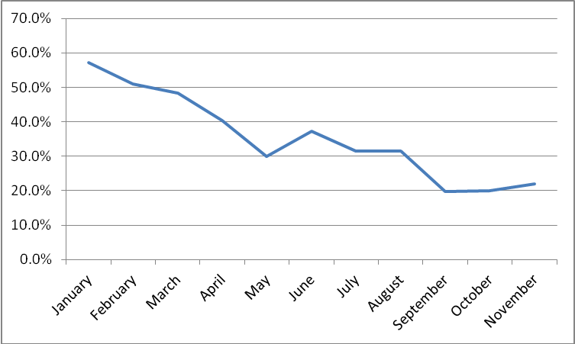

Figures 4 and 5 display the advertising activity in the top eight U.S. Senate races by different types of sponsors (candidates, party/coordinated and groups) from September 1 to Election Day. Similar to the advantage figure, the y-axis on the figures shows pro-Republican airings in thousands from 0 to 2 and pro-Democratic airings from 0 to -2 with the color of shading indicating the volume of advertising by each sponsor type for each day on the x-axis (brightest shading indicates candidate airings, darkest is for groups while lightest is for party and/or coordinated spots). While most races show a ramping up of advertising volume as Election Day approaches, in a few of the races, most notably Alaska and Arkansas, advertising was more consistent over time. Georgia’s race did not really explode until well into October.

Figure 4: Volume of Advertising by Sponsor over Time (AK, AR, CO, & and GA)



Figure 5: Volume of Advertising by Sponsor over Time (IO, KY, LA, & NC)



The bottom right panel in Figure 5 shows clearly why North Carolina’s race took the top spot for volume, with pro-Democratic airings approaching 1,500 airings *per day* in late October. If one were to include the roughly 700 pro-Republican airings per day during that period, it would take nearly 18 hours of viewing to watch all of the political ads airing on North Carolina’s airwaves each day. One can also see the variable activity of different actors over time across different races. While pro-Democratic groups spent on behalf of Kay Hagan throughout the general election, their activity ramped up in the final few days of the North Carolina race. In contrast, pro-Democratic groups were active early in the Kentucky race on behalf of Alison Lundergan Grimes, but they were absent from mid-September through mid-October, and did not really take an active role again until the final week.

On the Republican side, although the overall percentage of Republican interest group activity was similar in Arkansas and Iowa, Figure 5 shows how many more pro-Republican group ads aired in Iowa on behalf of Joni Ernst. In addition, the Colorado panel shows how much more active Republican groups were compared to the Gardner campaign in September in particular. Louisiana is notable largely for the absence of group activity relative to other hotly contested races.

Table 11 provides more detail on the involvement of groups in specific races, with races featuring a greater percentage of group-sponsored ads at top of the table. In Michigan’s Senate race, for example, 51.1 percent of ads aired from January 1 to Election Day were sponsored by groups, followed by North Carolina at 51 percent. The percentage of total ads sponsored by groups exceeded 40 percent in six different Senate races. Note also the last two columns of the table, which show the percentage of total ads in the race that were sponsored by Democratic groups and Republican groups. In six of the ten races, Republican groups sponsored a greater percentage of ads than did Democratic groups.

|  |  |  |  |
| --- | --- | --- | --- |
| Table 11: Percentage of Top Senate Race Advertising Sponsored by Groups (January 1-Election Day) | | | |
|  |  |  |  |
| State | Total IG % | Pro-Dem IG % | Pro-GOP IG % |
| Michigan | 53.1% | 30.5% | 22.6% |
| North Carolina | 51.0% | 27.0% | 24.0% |
| Arkansas | 49.6% | 18.5% | 31.1% |
| Iowa | 47.7% | 19.2% | 28.5% |
| Colorado | 47.0% | 19.2% | 27.8% |
| Alaska | 40.9% | 21.4% | 19.6% |
| Kentucky | 35.0% | 10.2% | 24.8% |
| New Hampshire | 28.4% | 10.6% | 17.7% |
| Georgia | 27.7% | 4.3% | 23.4% |
| South Dakota | 27.7% | 25.3% | 2.4% |

There were even a few races in which a single outside group spent more than a candidate in that same race. In Colorado’s Senate race, for instance, Crossroads Grassroots Policy Strategies spent an estimated $6.5 million on advertising favoring Republican candidate Cory Gardner, which is considerably more than the estimated $5.2 million that the Gardner campaign itself spent. North Carolina provides a different kind of example. The Democratic group Senate Majority PAC spent over $9 million on ads in the race, far surpassing the estimated $5.4 million that Republican Thom Tillis spent.

Table 12 provides the same information for gubernatorial races. Topping the list is Michigan, where over 61 percent of ads were sponsored by groups. In both the Kansas and Colorado gubernatorial races, over 50 percent of ads were sponsored by groups. In five of the top 10 races, Democratic groups sponsored more ads than did Republican groups. Of the 147,000-plus ads sponsored by groups in gubernatorial races, almost 55,000 were sponsored by the Republican Governors Association (RGA) and its offshoots, while another 21,000 were sponsored by the Democratic Governors Association (DGA). Both the RGA and the DGA are 527 organizations, but they resemble parties more than most other groups that sponsor advertising, given that they are headed by elected party officials and have explicit goals of electing co-partisans.

|  |  |  |  |
| --- | --- | --- | --- |
| Table 12: Percentage of Top Gubernatorial Races Ads Sponsored by Groups (January 1-Election Day) | | | |
|  |  |  |  |
| State | Group ads | Pro-Dem group ads | Pro-GOP group ads |
| Michigan | 61.4% | 33.7% | 27.7% |
| Kansas | 54.9% | 20.3% | 34.6% |
| Colorado | 53.4% | 35.4% | 18.1% |
| Maine | 41.4% | 26.8% | 14.6% |
| Arkansas | 40.8% | 15.4% | 25.4% |
| Connecticut | 40.3% | 29.7% | 10.6% |
| Wisconsin | 29.1% | 19.3% | 9.8% |
| Arizona | 25.5% | 1.9% | 23.6% |
| Ohio | 25.2% | 0.8% | 24.4% |
| Florida | 20.1% | 3.4% | 16.7% |

Also notable is that the number of groups involved in House, Senate, and gubernatorial races in 2014 was up considerably from the previous election cycles. Our data tracked 254 groups that aired ads between January 1, 2014, and Election Day, which is almost 100 more than the 156 groups involved in House, Senate, and gubernatorial races during the same period in 2012. This suggests that several new interest-group players popped up in 2014. Indeed, 34 of the groups that were involved in advertising in 2014 appeared during the last two weeks of the campaign. We will expand upon the known effects of unknown groups in the conclusion.

**The Year of Dark Money**

Given the appearance of various group in the 2014 campaigns, much attention has been focused on so-called “dark money” groups—those who do not disclose their donors. These are organized as “non-profit” 501(c) organizations and thus legally must restrict their political activity to less than half of their total activity. In addition, some groups provide partial disclosure of donors. This occurs in two situations. The first is when a Super PAC reports receiving more than minimal donations from a non-disclosing 501(c) organization. The second is when a 501(c) group voluntarily discloses some but not all of its donors.

Table 13 shows the percentage of interest group spending—and ad counts—that fall into each disclosure category. Just over 58 percent of ad spending came from groups that fully disclose their donors, while 35.4 percent of ad spending came from groups that do not disclose. Another 6.4 percent of spending then came from groups that only partially disclose their funders. If one looks at ad counts as opposed to ad spending, the percentages shift a bit, with 40 percent of ads falling into the “no disclosure” category. Disclosure of donors was imbalanced across the parties in 2014, with Democratic groups providing more information about their donors. About 79 percent of pro-Democratic ad spending was full disclosure, while about 42 percent of pro-Republican ad spending was full disclosure. About 18 percent of Democratic group spending was dark money compared to 49 percent on the Republican side.

|  |  |  |  |  |  |  |  |  |
| --- | --- | --- | --- | --- | --- | --- | --- | --- |
| Table 13: Percentage of Group Estimated Spending by Groups and Airings by Disclosure Type in House, Senate and Gubernatorial Races (January 1-Election Day) | | | | | | | | |
|  |  |  |  | |  |  | |  |
|  | Total | | Pro-Democratic | | | Pro-Republican | | |
|  | Est. $ | Airings | Est. $ | Airings | | Est. $ | Airings | |
| Fully disclose | 58.2% | 54.9% | 78.9% | 73.6% | | 41.7% | 39.6% | |
| Partially disclose | 6.4% | 4.8% | 3.2% | 2.9% | | 9.2% | 6.5% | |
| No disclosure | 35.4% | 40.3% | 17.9% | 23.4% | | 49.1% | 53.9% | |
|  |  |  |  |  | |  |  | |
| Disclosure information provided by the Center for Responsive Politics | | | | | | | | |

Figure 6 displays the percentage of group-sponsored ads over the course of the campaign that were aired by those that did provide full disclosure of their donors. In general, disclosure increases until June before dropping in the summer months and then increases as Election Day approaches. This pattern is consistent with the idea that 501(c) groups, which are allegedly non-political non-profits, reduce their electoral involvement in the Federal Election Commission reporting windows before primary races—many of which occur in the spring—and again before Election Day so as to avoid the appearance of being too political and to avoid having to report their activity to the FEC.

Figure 6: Percentage of Interest Group Ads Aired by Full-Disclosure Groups

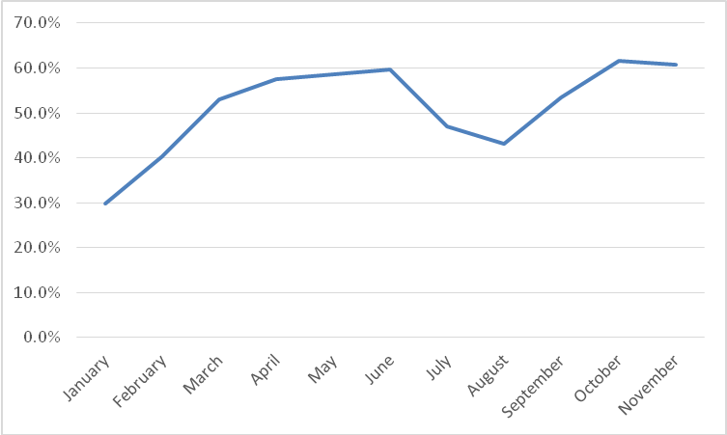

For those who care about transparency in elections, the growth of dark money activity by organizations that do not report their donors and frequently do not report their activity to the Federal Election Commission (as much of it falls outside of the mandatory reporting windows) is a troubling development. Research suggests that dark money advertising—like advertising from other unknown interest groups—is more effective than candidate, party, and known group advertising (for evidence and discussion on this topic, please see our concluding thoughts). But perhaps more importantly, it is very difficult to track and determine how much of this activity is occurring in elections, without access to an alternative data source like the tracking data provided by Kantar Media/CMAG through WMP or the Federal Communications Commission (FCC) database.

**The Year of Plateauing Negativity**

After seeing a decade of increasing negativity in House and Senate races, negativity (along with ad volumes) appears to have finally plateaued, as Figure 7 shows. Just over 50 percent of ads aired in congressional races between September 1 and Election Day were negative, that is, they focused on an opponent.[4] This was a drop from about 52 percent in 2012 and about 55 percent in 2010. Another 22.9 percent of ads in 2014 were contrast ads—they mentioned both the favored candidate and the opponent—while 26.4 percent were positive ads in that they only mentioned a favored candidate.

Part of the (slight) reduction in negativity is that some interest-group sponsors, especially on the Republican side, toyed with something new: airing contrast and even positive ads. This move away from negativity was likely driven by a regulatory environment in which groups no longer feared being punished for “coordinating” with candidates. Indeed, some candidates even encouraged groups to run positive ads on their behalf by posting high-resolution b-roll footage online in the hopes that supportive Super PACs and 501(c) organizations would use it in their ads (Goldmacher 2014).

Figure 7: Tone of Advertising by Year in Senate and House Races (September 1-Election Day)

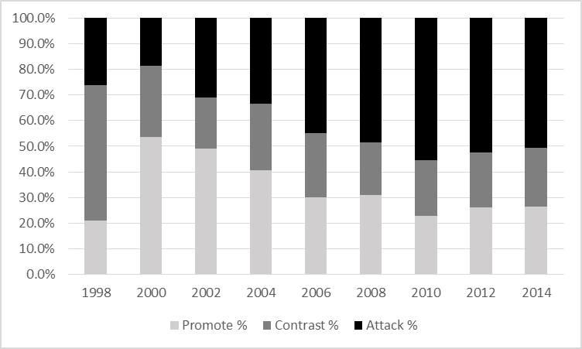

**The Year without a Theme**

One common refrain in news media coverage of the 2014 midterms was that the election lacked a prominent theme. Reporters at *The* *Washington Post* went so far as to say, “This is an election about nothing – and everything” (Rucker, Costa, and Gold 2014). And relative to the 2010 midterms following the recession, there certainly was a decline in a prevailing focus on the economy, though references to jobs still played a prominent role in many races. To the extent that there was a prominent theme, it was Obamacare—at least for Republicans. The ACA was the top issue mentioned in pro-Republican Senate airings (28.6 percent), followed by jobs (23 percent) and the deficit (15.6 percent). Pro-Democratic Senate airings, on the other hand, were more likely to focus on taxes (24.7 percent), followed by jobs (18 percent) and Medicare and Social Security (14.9 percent each).

|  |  |  |
| --- | --- | --- |
| Table 14. Top Issues in Top U.S. Senate Races by Favored Party (September 1 to Election Day) | | |
|  |  |  |
| State | Pro-Democratic | Pro-Republican |
| North Carolina | Taxes (42%) | Deficit/budget (20%) |
| Iowa | Social security (40%) | Veterans (26%) |
| Kentucky | Jobs (51%) | Jobs (25%) |
| Colorado | Abortion (43%) | Energy (24%) |
| Louisiana | Medicare (33%) | Immigration (61%) |
| Georgia | Jobs (38%) | Jobs (50%) |
| Arkansas | Medicare (34%) | Obamacare (44%) |
| Alaska | Local issues (29%) | Obamacare (34%) |
| Michigan | Environment (31%) | Jobs (42%) |
| Kansas* | Business (21%) | Obamacare (42%) |
|  |  |  |
| *Kansas independent candidate Greg Orman’s top issue is presented in the Pro-Democratic column. | | |

These aggregate findings, however, obscure the wide variation in issue topics by state. One can especially see the evidence for the lack of an overarching theme by examining the top issue by party in each of the top Senate contests as displayed in Table 14. Obamacare was the top issue in pro-Republican airings in three out of ten of the top Senate races (Arkansas, Alaska, and Kansas) while jobs topped the set of issues discussed in pro-Republican airings in another three states (Kentucky, Georgia, and Michigan). Pro-Democratic airings were more varied in focus across the top ten. Pro-Democratic airings in Kentucky and Georgia discussed jobs more than any other issue; pro-Democratic airings in Louisiana and Arkansas mentioned Medicare; and the remaining six races featured a different top issue mention, ranging from abortion (43 percent of pro-Udall airings in Colorado) to taxes (42 percent of pro-Hagan airings in North Carolina) to Social Security (40 percent of pro-Braley airings in Iowa) to the environment (31 percent of pro-Peters airings in Michigan).

As shown in Table 15, taxes topped the list of issues mentioned in U.S. House ads between September 1 and Election Day, and this was true in both pro-Democratic ads (29 percent) and pro-Republican ads (27 percent). References to jobs and employment also made the top five in both parties, with Republicans airing slightly more ads speaking to the issue (22.8 percent compared to 16.7 percent for Democrats). Beyond that, however, airings supporting each party diverged. Medicare was the second most mentioned issue in pro-Democratic ad airings (20 percent) followed by Social Security (17.7 percent) and education/schools (15 percent). More than one in four (26 percent) pro-Republican ad airings mentioned Obamacare. Budget deficits (17 percent) and government spending (15 percent) rounded out the top five issues mentioned in pro-Republican ad airings.

|  |  |  |  |  |
| --- | --- | --- | --- | --- |
| Table 15. Top Issues in U.S. House Races by Favored Party (September 1 to Election Day) | | | | |
|  |  |  |  |  |
| Issue | Pro-Democratic |  | Issue | Pro-Republican |
| Taxes | 29.1% |  | Taxes | 27.4% |
| Medicare | 20.3% |  | ACA/Obamacare | 26.1% |
| Social Security | 17.7% |  | Employment/Jobs | 22.8% |
| Employment/Jobs | 16.7% |  | Deficit/Budget/Debt | 17.2% |
| Education/Schools | 15.3% |  | Gov't spending | 15.2% |
| Veterans | 12.5% |  | Medicare | 14.3% |
| Deficit/Budget/Debt | 11.7% |  | Ethics/Scandal | 9.1% |
| Gov’t shutdown | 10.8% |  | Energy Policy | 7.2% |
| Ethics/Scandal | 9.4% |  | Veterans | 7.0% |
| Health care | 8.0% |  | Business (friend of) | 7.0% |
| Gov't spending | 7.7% |  | Economy (generic) | 6.8% |
| Abortion | 6.9% |  | Health care | 6.6% |
| Local issues | 6.5% |  | Immigration | 6.3% |
| Women's health | 6.2% |  | Gov’t regulations | 4.4% |
| Business (friend of) | 5.4% |  | Local issues | 4.2% |

Gubernatorial ads, in contrast to U.S. Senate ads, were more likely to stick to similar issue references both across states (not shown) and even, to some extent, across party lines. Table 16 displays the breakdown by party of all coded gubernatorial airings between September 1 and Election Day. As shown by the table, the top three issue mentions for both parties were the same, just in reverse order. Pro-Democratic airings focused primarily on education (45 percent), followed by taxes (31 percent) and jobs at a close third (31 percent). Pro-Republican airings were most likely to mention jobs (44 percent), but one in three mentioned taxes (33 percent), and one in four touched on schools and education (25 percent).

|  |  |  |  |  |
| --- | --- | --- | --- | --- |
| Table 16: Top Issues in Gubernatorial Airings by Favored Party (September 1 to Election Day) | | | | |
|  |  |  |  |  |
| Issue | Pro-Democratic |  | Issue | Pro-Republican |
| Education/Schools | 45.3% |  | Employment/Jobs | 44.0% |
| Taxes | 30.9% |  | Taxes | 33.3% |
| Employment/Jobs | 30.5% |  | Education/Schools | 25.2% |
| Economy (generic) | 18.1% |  | ACA/Obamacare | 11.9% |
| Gov’t Ethics/Scandal | 16.9% |  | Business (friend of) | 11.7% |
| Deficit/Budget/Debt | 10.8% |  | Gov't spending | 10.5% |
| Health Care | 7.7% |  | Deficit/Budget/Debt | 10.0% |
| Business (friend of) | 6.3% |  | Gov’t Ethics/Scandal | 10.0% |
| Abortion | 5.6% |  | Economy (generic) | 7.8% |
| Medicare | 5.0% |  | Moral/Family/Values | 6.4% |
| Minimum wage | 3.9% |  | Local Issues | 6.2% |
| Housing/Sub-prime mortgages | 3.8% |  | Immigration | 4.7% |
| Local Issues | 3.7% |  | Gov't regulations | 4.2% |
| Energy Policy | 2.7% |  | Welfare | 2.9% |
| Gov't spending | 2.7% |  | Abortion | 2.6% |

Although Obamacare did not make the list of top three issues in pro-Republican gubernatorial airings, it is noteworthy that it did rank number four with nearly 12 percent of airings containing a reference to the law. Pro-Democratic airings—similar to House and Senate ads—ignored the issue, preferring instead to reference health care generically (nearly 8 percent) or Medicare (5 percent of airings).

**Conclusions**

Advertising in the 2014 midterm elections was similar to past cycles in terms of the volume of activity and levels of negativity but was more noteworthy in terms of the involvement of outside groups in Senate races, the extent to which dark money groups sponsored advertising, and the degree to which no issue dominated the campaign discourse. Thinking ahead to advertising in 2016, what can we expect?

First, data from 2014 suggest that the huge rises in the volume of broadcast television advertising that were evident in the first decade of the 2000s are no longer ongoing. While there is still certainly a desirable audience to be found watching broadcast television, namely, older viewers with a high propensity for voting, viewership of broadcast television is declining, especially among young people who are increasingly switching to video on demand. Moreover, local cable television and online advertising provide venues for more targeted advertising and thus a more efficient use of advertising dollars. No doubt broadcast television will remain important in 2016, but double-digit increases in ad volumes on broadcast television are likely a thing of the past.

Second, an increasing share of ads will be sponsored by 501(c) organizations and Super PACs. The Supreme Court has made clear in recent years that attempts to stop the flood of cash entering the campaign finance system will not pass constitutional muster. At the same time, the Federal Election Commission and the IRS have shown that they are unable or unwilling to enforce laws on the books regarding electioneering and coordination among various actors. Thus, it is arguably easier than at any point since the 1970s for wealthy donors to get money into the system and for groups to spend that money on electioneering.

In such a system, the potential for groups to set the campaign agenda is greater than ever. This will be especially evident in the most competitive races. We saw in 2014 that group-sponsored ads constituted a majority or near-majority in many of these highly competitive contests. The ability of groups to set the agenda will also be high in primary races. Recall that over half of the ads that aired in January and February of 2014 were sponsored by groups. The presidential primaries in 2012 witnessed skyrocketing levels of interest group activity, and we have every reason to believe that groups will continue to be involved, perhaps even more heavily than in 2012. And while this may make it increasingly hard for candidates to control the agenda, that depends to some extent upon the creative ways in which groups are able to follow what candidates would prefer to discuss anyway. The already-mentioned lack of enforcement of coordination bans may embolden groups to work alongside candidates in sending a consistent message to voters.

There are some potentially troubling aspects of groups’ sponsoring a greater percentage of ads in the future. One is the simple fact that voters do not know where the money is coming from when the sponsor is a dark money group. What is more, a growing body of evidence suggests that ads sponsored by groups about which citizens know very little are more effective than ads sponsored by candidates or parties (Brooks and Murov 2012; Weber, Dunaway, and Johnson 2012; Dowling and Wichowsky, forthcoming; Johnson, Dunaway, and Weber 2011; Ridout, Franz, and Fowler, forthcoming). This may only serve to encourage the growth of dark money and of newer interest group involvement more broadly as survey evidence suggests that Americans know very little about even the most active full disclosure interest group organizations (e.g., American Crossroads or Senate Majority PAC) in elections.

The 2016 elections will also continue to blur the lines between sponsors. The traditional division of ad sponsorship among candidates, parties, and interest groups may no longer make much sense. Most groups that sponsor ads today have no connection to a membership-based organization. Rather, they are legal entities often with networks (such as the Koch Brothers’ ever-expanding organizational chart with innocuous-sounding names). The 2014 elections also saw the growth of single-candidate organizations, such as the Kentucky Opportunity Coalition, which aired over 11,000 ads promoting Senator Mitch McConnell and attacking his opponent. All presidential candidates in 2016 will likely have a preferred Super PAC—one operated by someone close to the campaign. And groups like Senate Majority PAC and Crossroads GPS make one wonder where parties end and groups begin.

**References**

Brooks, Deborah Jordan and Michael Murov. 2012. “Assessing Accountability in a Post-Citizens United Era: The Effects of Attack Ad Sponsorship by Unknown Independent Groups.” *American Politics Research* 40(3): 383-418.

Dowling, Conor M., and Amber Wichowsky. Forthcoming. “Attacks without Consequence? Candidates, Parties, Groups, and the Changing Face of Negative Advertising.” *American Journal of Political Science*.

Goldmacher, Shane. March 12, 2014. “The Actual Intention behind That Awkward Mitch McConnell Video.” *National Journal*.

Issenberg, Sasha. 2012. *The Victory Lab: The Secret Science of Winning Campaigns*. Random House.

Johnson, Tyler, Johanna Dunaway and Christopher R. Weber. 2011. “Consider the Source: Variations in the Effects of Negative Campaign Messages.” *Journal of Integrated Social Sciences* 2(1): 98-127.

Klimas, Jacqueline. September 24, 2014. “Online Campaign Ads May Prove Decisive in Midterm Elections.” *The Washington Times*.

Kucinich, Jackie. October 29, 2014. “For Planned Parenthood Votes and Americans for Prosperity in N.C., It’s All about the Ground Game.” *The Washington Post*.

Ridout, Travis N., Michael M. Franz and Erika Franklin Fowler. Forthcoming. “Sponsorship,

Disclosure and Donors: Limiting the Impact of Outside Group Ads. *Political Research*

*Quarterly*.

Rucker, Philip, Robert Costa and Matea Gold. August 9, 2014. “Unlike Previous Midterm Election Years, No Dominant Theme Has Emerged for 2014.” *The Washington Post*.

Weber, Christopher, Johanna Dunaway and Tyler Johnson. 2012. “It’s All in the Name: Source Cue Ambiguity and the Persuasive Appeal of Campaign Ads.” *Political Behavior* 34(3): 561-584.

1. We have many to thank for their assistance in making this research a reality, including Michael Franz, co-director of the Wesleyan Media Project; Laura Baum, WMP project manager; and Robert McGuire of the Center for Responsive Politics, who provided us with the group disclosure classifications. We also thank our student research assistants at all three institutions for their tireless work, and we thank the John S. and James L. Knight Foundation, the John D. and Catherine T. MacArthur Foundation, and Wesleyan University for their financial support of the project.
2. Data presented here are based on ongoing Wesleyan Media Project coding of Kantar Media/CMAG video, which at the time of this writing is 91 percent complete for federal and gubernatorial airings from the period September 1 through Election Day (97.5 percent complete for U.S. Senate airings, 88.8 percent complete for U.S. House airings and 87.2 percent complete for gubernatorial airings).
3. We compared WMP coding with Kantar Media/CMAG coding on several variables. We had 94 percent agreement and a Kappa of 0.91 for tone (positive, negative, contrast); 94 percent agreement (Kappa=0.86) for the issue of taxes; 94 percent agreement (Kappa=0.86) for jobs; 99 percent agreement (Kappa=0.93) for abortion; 98 percent agreement (Kappa=0.93) for education; 98 percent agreement (Kappa=0.94) for Medicare; 98 percent agreement (Kappa=0.87) for veterans; 99 percent agreement (Kappa=0.90) for immigration and 97 percent agreement (Kappa=0.88) for the Affordable Care Act. Two problem areas were for the issues of the debt/deficit/budgets (71 percent agreement; Kappa=.30) and for government spending (68 percent agreement; Kappa=.21). These low levels of agreement are likely due to the slightly different issue categorizations that the WMP and Kantar Media/CMAG employ.
4. These percentages are restricted to the 75 largest media markets given that we have access to ad data only from those markets in the early years of the time series.